

**Project Status Report**



**Project Name:** Barcode Info

**Department:** BSCS or Bachelor of Science in Computer Science

**Focus Area:** Weather Stations

**Product/Process:** Preventive Maintenance of Weather Stations



**Prepared By:**

|  |  |
| --- | --- |
| **Document Owner(s)** | **Project/Organization Role** |
| Miguel Mayor | Project Manager |
| Joanna De Guzman | Project Editor |
| Adrian Tobias | Project Researcher |

**Project Status Report Version Control**

|  |  |  |  |
| --- | --- | --- | --- |
| **Version** | **Date** | **Author** | **Change Description** |
| 1.0 | 04/13/16 | Miguel Mayor | Document created |
| 1.1 | 04/20/16 | Miguel Mayor | * Statement of the Problem was more specific * Solutions that were in the paper was removed * Paper was modified in a way that it expands what data is used and it focused more on the problem |
|  |  |  |  |

**TABLE OF CONTENTS**

1 PROJECT STATUS REPORT PURPOSE 3

2 PROJECT STATUS REPORT TEMPLATE 3

2.1 Project Status Report Details 3

2.2 Project Status Report Template 3

3 PROJECT STATUS REPORT APPROVALS 3

4 APPENDICES 3

4.1 Document Guidelines 3

4.2 Project Status Report Sections Omitted 3

# PROJECT STATUS REPORT PURPOSE

The Project Status Report is a document that Project Managers may use as a means of formal regular reporting on the status of a project to key project stakeholders, including the Steering Committee, Project Sponsor, and Senior Manager.



# PROJECT STATUS REPORT TEMPLATE

## Project Status Report Details

* [Status of the Project]
  + Project Barcode Info plans to design an improved system for the Operations and Maintenance of weather.com.ph by using a more modern algorithm that will provide faster results and convenience compared to the older system.
  + Milestone Deliverable/s: Barcode Info paper for proofreading and approval by project adviser
  + Due to the numerous comments and corrections of the project advisor, the project is slightly delayed. Though there has been a delay, these changes could lead to further improvement of the system.

* [Budget Report]
  + Food and Beverages – ₱ 523
  + Transportation - ₱ 310

* [Risk Management Report—Specify any changes to the major risks identified since the previous report and modification to the strategies put in place to manage them, if appropriate.]
  + Solution was removed and a new way was discussed to address the problem specifically through the use of algorithm layout of the old system.

* [Issues Report]
  + Unsure of the specific details of what medium needs to be used in the system
  + Possible ways of measuring is still also unclear
* (Recommendations) If one decides to replicate or improve the project, it is recommended that improvements will focus on expanding the system by increasing the speed, reliability, and convenience of the system not only in the software aspect, but as well as in the whole algorithm of the entire system.

## Project Status Report Template

|  |  |  |
| --- | --- | --- |
| Barcode Info | | |
| Prepared By:  Adrian Tobias | Date:  06/23/16 | Reporting Period:  6/23/16 to 6/24/16 |
| Project Overall Status:   * Paper is moved to the research and theoretical path from the software development path | | |
| Project Summary:   * Currently ongoing improvements on the document aspect | | |
| **Milestone Deliverables performance reporting over last period**   |  |  |  |  | | --- | --- | --- | --- | | **Milestone Deliverables** | **Due Date** | **% Completed** | **Deliverable Status** | | Milestone 1 | | | | | * Presentation of Data Gathering | 02/05/16 | 40% | On Schedule | | * Consultation with Project Advisor | 02/09/16 | 100% | On Schedule | | * Paper on Barcode Info | 04/13/16 | 40% | On Schedule | | Milestone 2 | | | | |  |  |  |  | |  |  |  |  | |  |  |  |  | | | |
| **Milestone Deliverables scheduled for completion over next period**   |  |  |  |  | | --- | --- | --- | --- | | **Milestone Deliverables** | **Due Date** | **% Completed** | **Deliverable Status** | | Milestone 1 | | | | | * Revised Version of Paper | 07/9/16 | 60% | On Schedule | | * Improvement of the parts of the paper | 06/30/16 | 0% | On Schedule | |  |  |  |  | | Milestone 2 | | | | | * Construction of algorithm of the old system | 07/16/16 | 0% | On Schedule | | * Construction of algorithm of the new system | 07/30/16 | 0% | On Schedule | | | |
| **Project impact of milestone success or failure for project remainder**   |  |  | | --- | --- | | Paper will be added new information and problem will be expanded by the use of mapping the system by flowchart | Paper was delayed because numerous needed changes for the paper to be updated | | | |
| **Project** **Budget/Financial Status**   |  |  |  |  | | --- | --- | --- | --- | | **Budget Item** | **Planned Budget** | **Actual Cost** | **Variance/Explanation** | | Food and Beverages | 1000 | 394 | Food and Beverages consumed | | Transportation | 500 | 230 | Taxi fee for transportation to APC | | | |
| **Project Risk Management Status**   |  |  |  |  |  | | --- | --- | --- | --- | --- | | **Risk and Description** | **Risk Chance** | **Risk Impact** | **Risk Priority** | **Change from Last Review** | | Will the new system improved the old system? | Medium | High | High |  | | | |
| **Project Issue Management Status**   |  |  |  |  |  | | --- | --- | --- | --- | --- | | **Issue and Description** | **Project Impact** | **Target Due Date** | **Issue Status** | **Issue Resolution** | | Delay of paper | High | 07/09/16 | Open | Paper should be presented for Project Advisor for proofreading and comments on the paper | | Other sections of the paper   * Statement of the Problem * Objectives | High | 06/30/16 | Open | Parts of the paper should be completed and should conform to the theoretical path | | | |
| **Project Recommendations**   |  | | --- | | * Will the project deliverables be completed within acceptable quality levels?   The deliverables will be submitted before their deadlines. The new requirements will be checked and verified by our Advisor   * Are project issues and risks being addressed successfully and mitigated?   Yes, they be addressed and we will make solutions to solve the problems and issues presented in this status report | |  | | | |
| **Objectives for Next Project Status Review**   |  | | --- | | * To accomplish the needed items for the paper before the next status report * To let the paper be commented and corrected by our Project Advisor * To get our paper up-to-date with the needed requirements | | | |
| **Related Project Information**   |  | | --- | |  | | | |



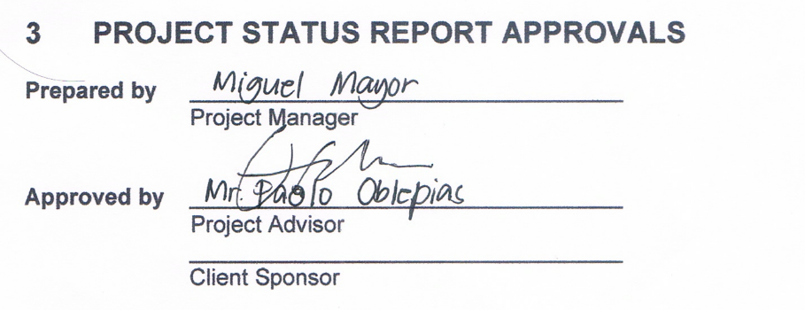



# APPENDICES

## Document Guidelines

## Project Status Report Sections Omitted

